DATA SHEET
MODEL No : CY-L42W/CY-L56W /CY-L98W/CY-L140W
LED Chip Brand : philips/Bridgelux/
Input Volage : AC100-240V 50/60Hz
Light Efficiency : >110m/W
Color Temperature : 3000K/4500K/6000K
Operating Temperature : -40℃ ±60℃
Warranty : 3years
Power Factor : >0.9
Color Rendering Index（Ra) : >70
Viewing Angle :
IP Grade : IP65
Material : Aluminium
Driver Brand : MOSO/Meanwell/Sosen
Order Information :

Part NO | Power | LED | Lumen | Size :cm | NW/GW | Installation
CY-L42W | 30W | SMD | 4500 | 57.5*24*16.5 | 3.68/3.18 | 4M
CY-L56W | 60W | SMD | 9000 | 67*30*18 | 5.45/4.69 | 6M
CY-L98W | 100W | SMD | 11500 | 79*34.5*21 | 8.5/7.5 | 8M
CY-L140W | 150W | SMD | 17250 | 90*38.5*21.5 | 10.6/12 | 10M

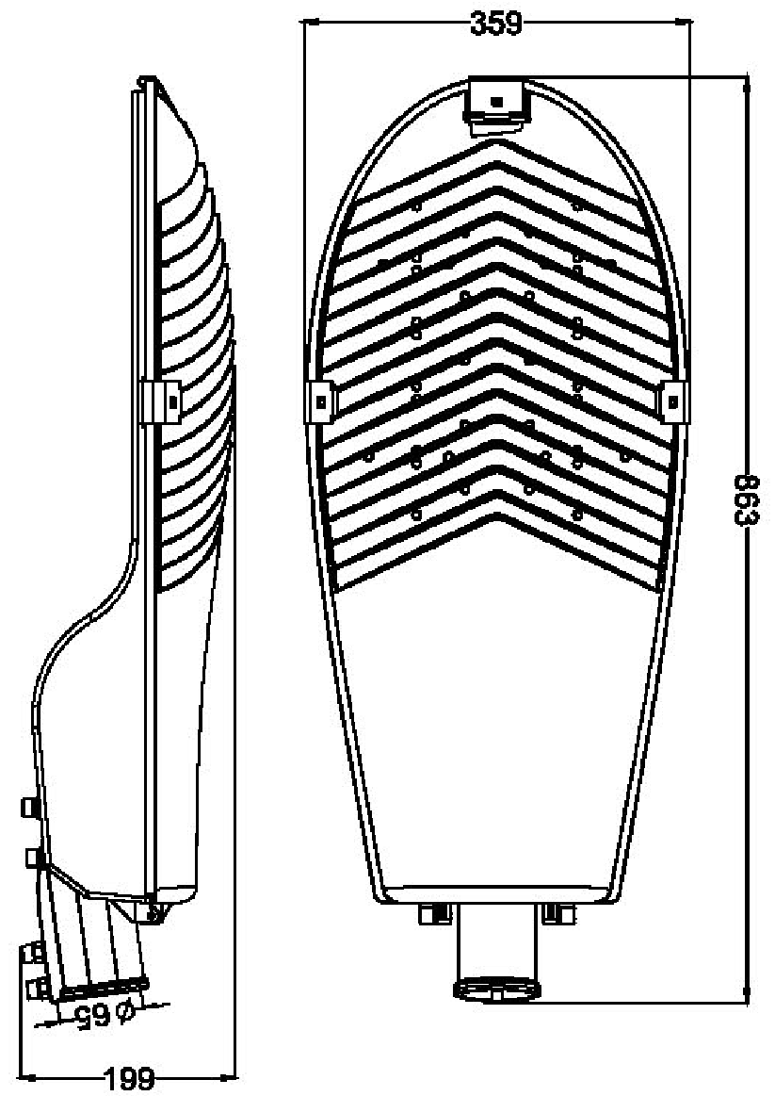
size:（±10mm）

Product picture
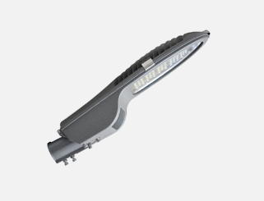

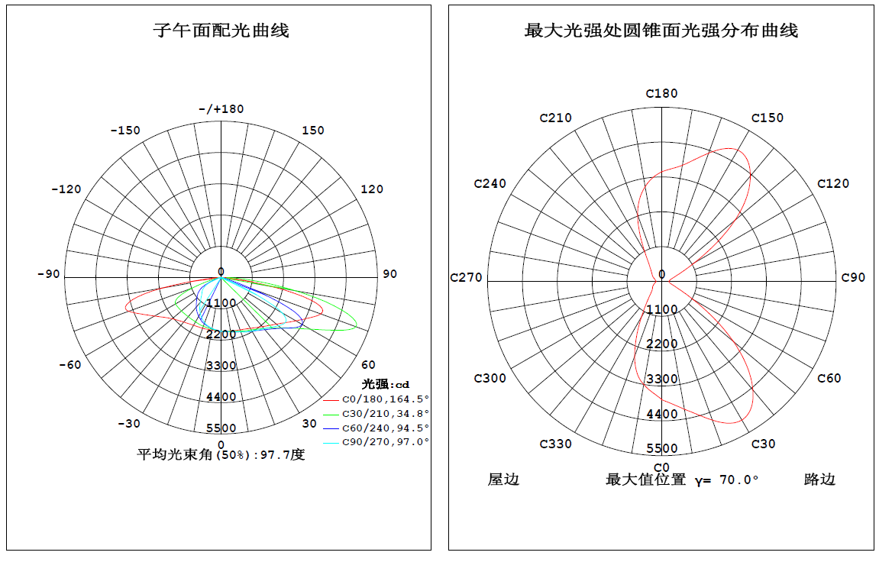
Light curve
Type Ⅱ短投射配光

