LED Chip Brand : philips/Bridgelux/
Input Volage : AC100-240V 50/60Hz
Light Efficiency : >110m/W
Color Temperature : 3000K/4500K/6000K
Operating Temperature : -40℃ ±60℃
Warranty : 3years
Power Factor : >0.9
Color Rendering Index（Ra) : >70
Viewing Angle : 180
IP Grade : IP65
Material : Aluminium
Driver Brand : MOSO/Meanwell/Sosen
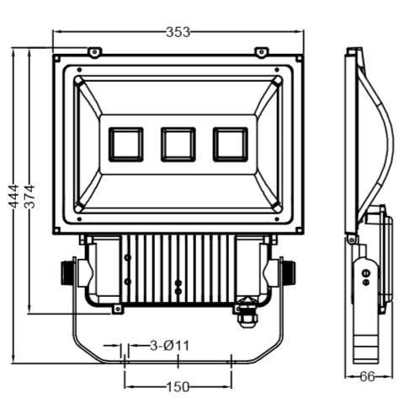
Dimension（±10mm）
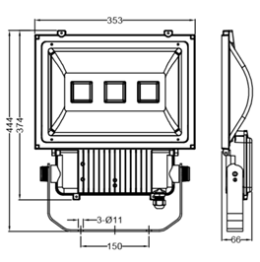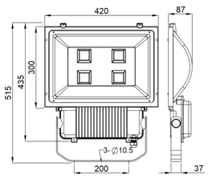
Model | Power | Package | Lumen | Packing size | GW/NW | Install height
CY-TY150W | 150W | SMD | 15000 | 44．5**353x6.6cm | 5.5/4.9 | 10M
CY-TY200W | 240W | SMD | 20000 | 49.5*47.5*8.7 cm | 8.57/7.47 | 15M

Photometric
TypeⅡ Curve


