LED Chip Brand : philips/Bridgelux/
Input Volage : AC100-240V 50/60Hz
Light Efficiency : >110m/W
Color Temperature : 3000K/4500K/6000K
Operating Temperature : -40℃ ±60℃
Warranty : 3years
Power Factor : >0.9
Color Rendering Index（Ra) : >70
Viewing Angle : 180
IP Grade : IP65
Material : Aluminium
Driver Brand : MOSO/Meanwell/Sosen
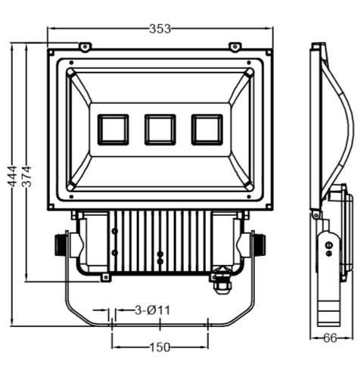
Dimension（±10mm）
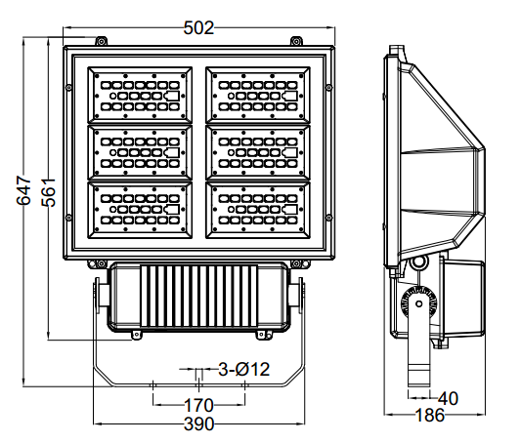
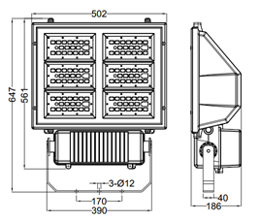
Model | Power | Package | Lumen | Packing size | GW/NW | Install height
CY-TZ300W | 240W | SMD | 33000 | 78*64*32 cm | 13.7/12.7 | 20-30M

Photometric
Type Ⅱ Curve


