DATA SHEET
MODEL No : CY-LD100W/CY-LC120W /CY-LC150W/CY-LC280W
LED Chip Brand : philips/osram/sumsung
Input Volage : AC100-240V 50/60Hz
Light Efficiency : 110m/W-150lumen
Color Temperature : 3000K/4500K/6000K
Operating Temperature : -40℃ ±60℃
Warranty : 3years
Power Factor : >0.9
Color Rendering Index（Ra) : >70
Viewing Angle :
IP Grade : IP65
Material : Aluminium
Driver Brand : MOSO/Meanwell/Sosen
Order Information :

Part NO | Power | LED | Lumen | Size :cm | NW/GW | Installation
CY-LD100W | 100W | SMD | 13000lumen | 500×416×204 | 6.3/7.3 | 6-8M
CY-LC120W | 120W | SMD | 14400lumen | 500×416×204 | 6.3/7.3 | 8-9M
CY-LC150W | 150W | SMD | 18000lumen | 578×416×204 | 7.6/8.6 | 10-12M
CY-LC280W | 280W | SMD | 32500lumen | 656×416×204 | 7.5/8.6 | 12-15M

size:（±10mm）
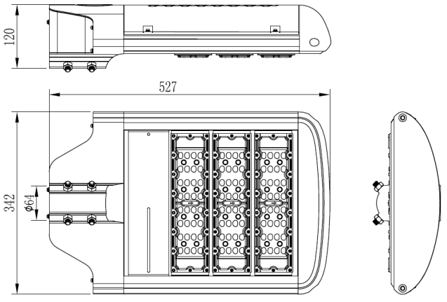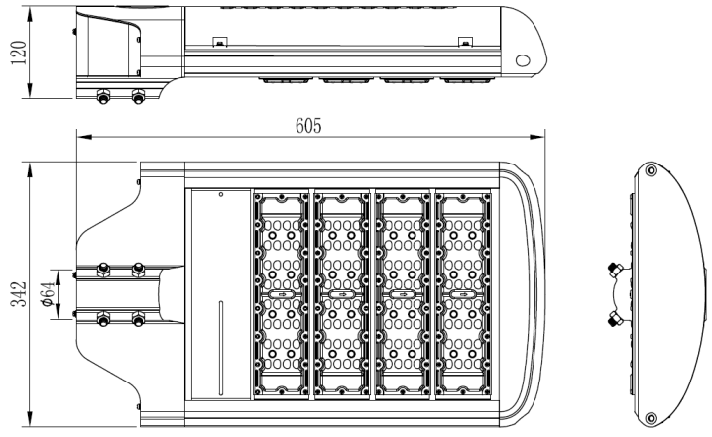

Product picture
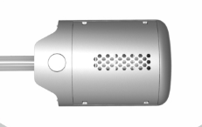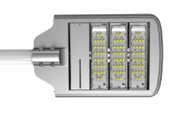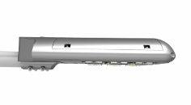

Light curve


