LED Chip Brand : philips/Bridgelux/
Input Volage : AC100-240V 50/60Hz
Light Efficiency : >110m/W
Color Temperature : 3000K/4500K/6000K
Operating Temperature : -40℃ ±60℃
Warranty : 3years
Power Factor : >0.9
Color Rendering Index（Ra) : >70
Viewing Angle : 180
IP Grade : IP65
Material : Aluminium
Size（±10mm）
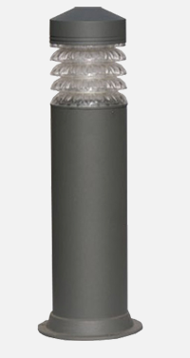
Model | Power | Package | Lumen | Packing size | GW/NW | Install height
CY-C150-20W | 10W/20W | E27/SMD | 2000 | 150*800 | 3 | 0.3-0.8M

