LED Chip Brand : philips/Bridgelux/
Input Volage : AC100-240V 50/60Hz
Light Efficiency : >110m/W
Color Temperature : 3000K/4500K/6000K
Operating Temperature : -40℃ ±60℃
Warranty : 3years
Power Factor : >0.9
Color Rendering Index（Ra) : >70
Viewing Angle : 180
IP Grade : IP65
Material : Aluminium
Driver Brand : MOSO/Meanwell/Sosen
Features :
1 High cost efficient
The compact design optimizes the construction, provides a very cost-efficient product
and guarantees the proper performance and durability.
2 Perfect heat dissipation
Pure aluminum heat sink is low weight and provides perfect heat management, guarantees
the Tj temperature of LED chip less than 80C @ Ta=25C for long lifespan of the LED.
Standardized LED module allows for fast maintenance and upgrade
3 Super light efficiency
The high light efficiency 150lm/W and the super cost-efficiency shorten
down the electricity bill sharply with low investment.
4 Long lifespan

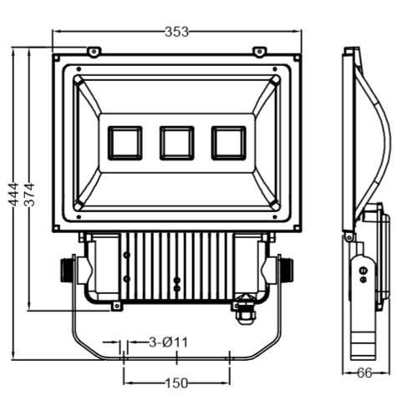
Dimension （±10mm）
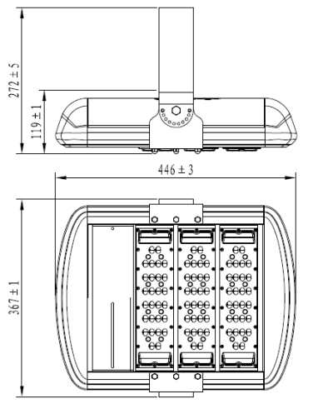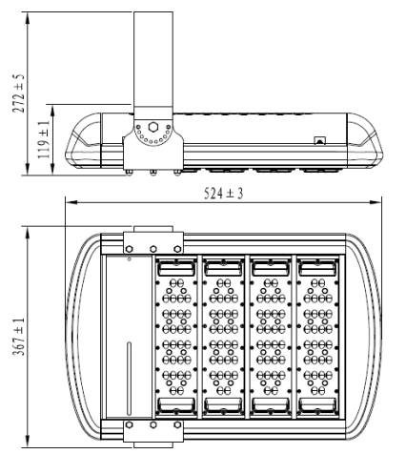
Model | Power | Package | Lumen | Packing size | GW/NW | Install height
CY-TZM200W | 200W | SMD | 22000 | 78*64*32 cm |  | 150-20M
CY-TZM280W | 280W | SMD | 33000 | 78*64*32 cm |  | 20-30M

Photometric
Type ⅡCurve


