Input Volage : AC100-240V 50/60Hz
Light Efficiency : >90m/W
Color Temperature : 3000K/4500K/6000K
Operating Temperature : -40℃ ±60℃
Warranty : 5years
Power Factor : >0.9
Color Rendering Index（Ra) : >70
Viewing Angle : 160
IP Grade : IP65
Material : Aluminium
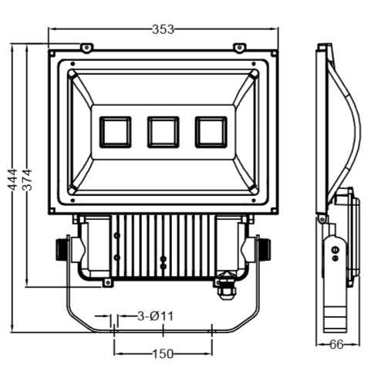
Dimension（±10mm）
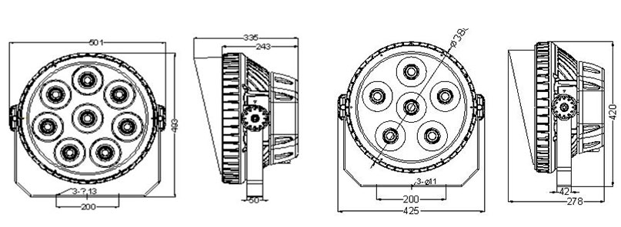
Model | Power | CCT | Lumen | Net weight | Voltage | Install height
CY-CA120W | 120watt | 3000-6000K | 2700 | 6.9KG | 100-277V | 7-12M
CY-CA150W | 150watt | 3000-6000K | 4500 | 12KG | 100-277V | 10-15M
CY-CA200W | 200watt | 3000-6000K | 9000 | 12KG | 100-277V | 15-20M
CY-CA240W | 240watt | 3000-6000K | 13500 | 12KG | 100-277V | 20-24M
CY-CA360W | 300W/360W | 3000-6000K | 18000 | 18KG | 100-277V | 20-30M
CY-CA600W | 500W/600W | 3000-6000K | 27000 | 29KG | 100-277V | 20-30M

Photometric
Type Ⅱ Curve



