Input Volage : AC100-240V 50/60Hz
Light Efficiency : >90m/W
Color Temperature : 3000K/4500K/6000K
Operating Temperature : -40℃ ±60℃
Warranty : 2years
Power Factor : >0.9
Color Rendering Index（Ra) : >70
Viewing Angle : 180
IP Grade : IP65
Material : Aluminium
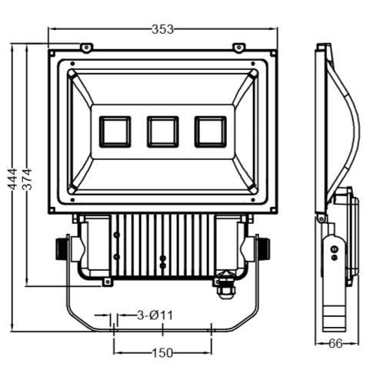
Dimension（±10mm）

Model | Power | CCT | Lumen | Net weight | Voltage | Install height
CY-TC30W | 30watt | 3000-6000K | 2700 | 1.0KG | 100-277V | 0-3M
CY-TC50W | 50watt | 3000-6000K | 4500 | 1.3KG | 100-277V | 3-5M
CY-TC100W | 100watt | 3000-6000K | 9000 | 3KG | 100-277V | 7-10M
CY-TC150W | 150watt | 3000-6000K | 13500 | 3.5KG | 100-277V | 8-12M
CY-TC200W | 200watt | 3000-6000K | 18000 | 4.7KG | 100-277V | 10-15M
CY-TC300W | 300watt | 3000-6000K | 27000 | 7KG | 100-277V | 15-25M
CY-TC400W | 400watt | 3000-6000K | 36000 | 9KG | 100-277V | 20M-30M

Photometric
Type Ⅱ Curve



