LED Chip Brand : philips/Bridgelux/
Input Volage : AC100-240V 50/60Hz
Light Efficiency : >130m/W
Color Temperature : 3000K/4500K/6000K
Operating Temperature : -40℃ ±60℃
Warranty : 5 years
Power Factor : >0.95
Color Rendering Index（Ra) : >70
Viewing Angle : 180
IP Grade : IP65
Material : Aluminium
LED brand : 
Driver Brand : MOSO/Meanwell/Sosen
Product picture :
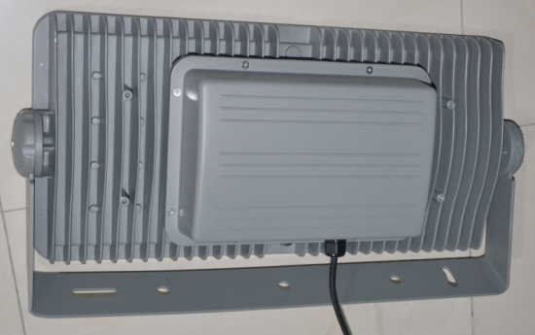
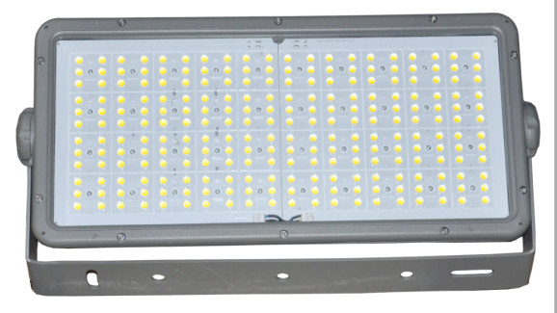
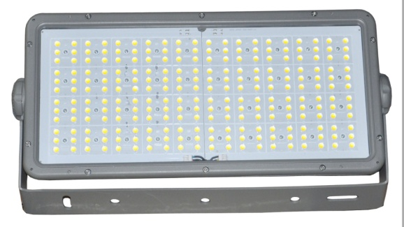

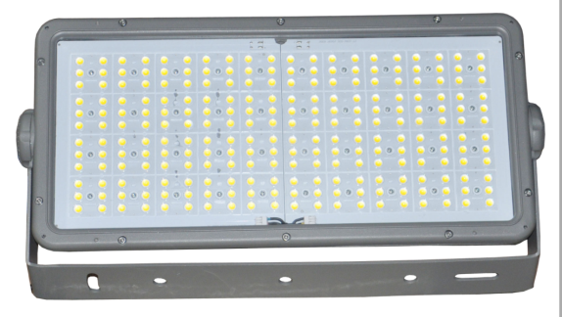

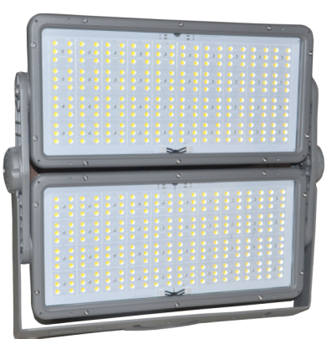
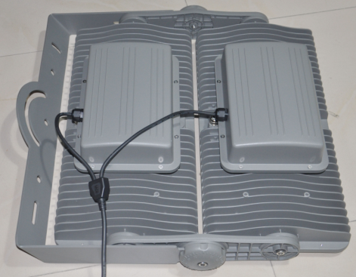

Dimension （±10mm）

Model | Power | Package | Lumen | Packing size | GW/NW | Install height
CY-TZY550W | 550W | SMD | 77000 | 42.5x40.5x14.5cm | 4.68KG | 15-38M
CY-TZY1066W | 1066W | SMD | 149000 | 42.5x40.5x14.5cm | 4.68KG | 25M to 50 M

Photometric
Type Ⅱ curve
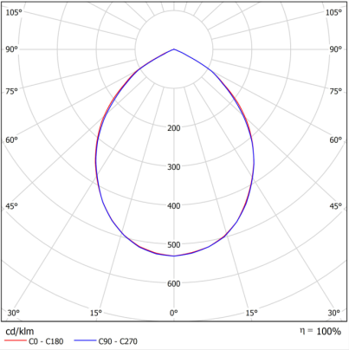
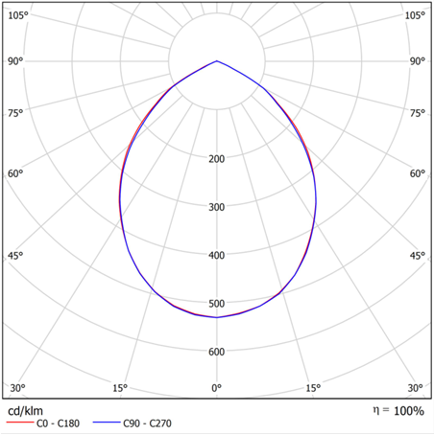
More can be customized


