DATA SHEET
MODEL No : CY-LZM30W/CY-LZM60W/CY-LZM100W/CY-LZM150W
LED Chip Brand : philips/Bridgelux/
Input Volage : AC100-240V 50/60Hz
Light Efficiency : >110m/W
Color Temperature : 3000K/4500K/6000K
Operating Temperature : -40℃ ±60℃
Warranty : 3years
Power Factor : >0.9
Color Rendering Index（Ra) : >70
Viewing Angle :
IP Grade : IP65
Material : Aluminium
Driver Brand : MOSO/Meanwell/Sosen
Order Information :

Part NO | Power | LED | Lumen | Size | NW/GW | Installation
CY-LZM30W | 30W | SMD | 4500 | 580*250*150 | 2.5/3.0 | 4M
CY-LZM60W | 60W | SMD | 9000 | 580*250*150 | 2.5/3.0 | 6M
CY-LZM100W | 100W | SMD | 11500 | 800*320*175 | 5.0/6.0 | 8M
CY-LZM150W | 150W | SMD | 17250 | 800*320*175 | 5.0/6.0 | 10M

size:（±10mm）

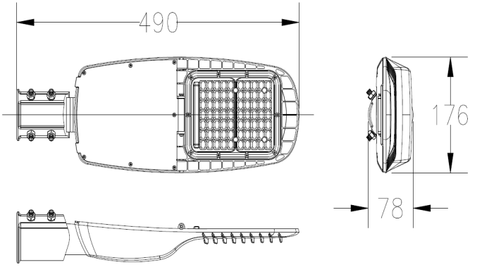
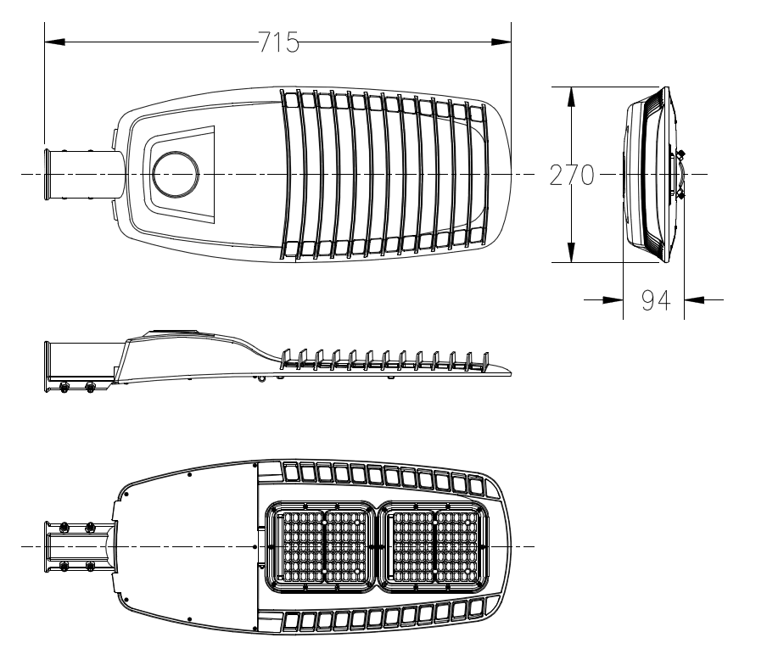

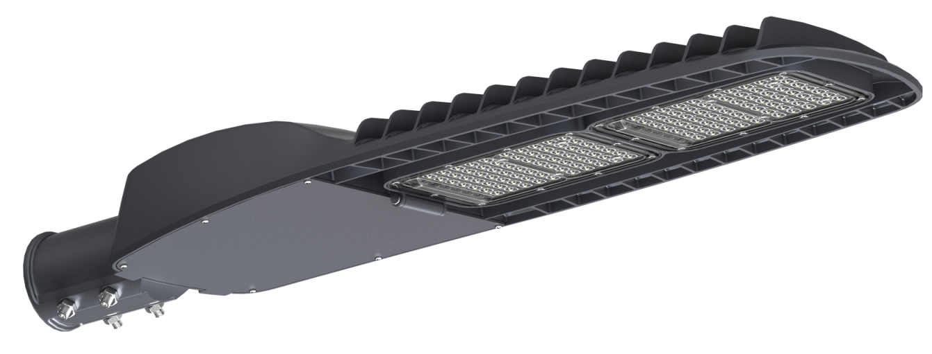
Product picture

Light curve
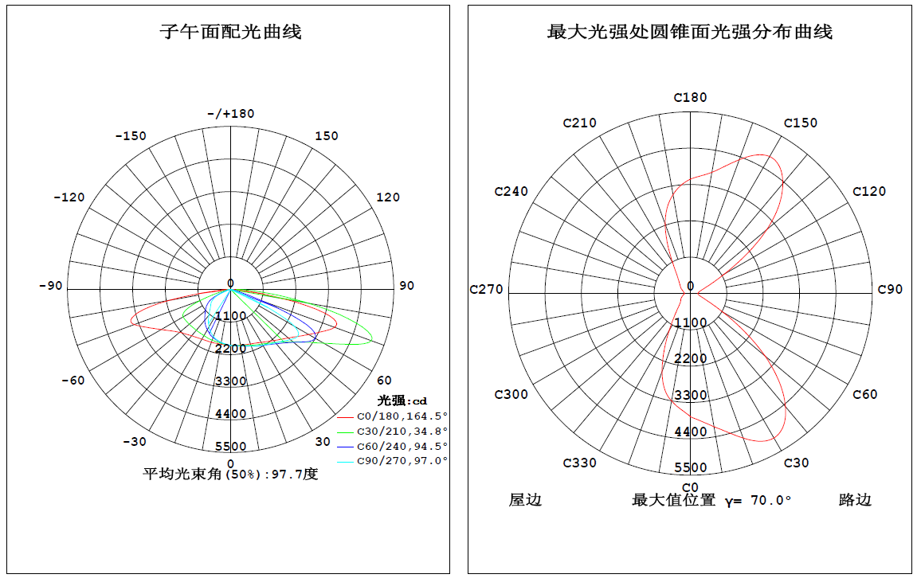
Type Ⅱ短投射配光

